Variable Selection:

|  |  |  |  |  |
| --- | --- | --- | --- | --- |
| Characteristic | Univariate | Domain | Model | Note |
| Demographic |  |  |  |  |
| Age at enrollment (mean) | P<0.0001* | √ | √ |  |
| Gender (%female) | P<0.0001* | √ | √ |  |
| Ethnicity (%black) | P=0.66 | X |  |  |
| Socioeconomic |  |  |  |  |
| Income (%yes) | P=0.017* | X | ? |  |
| Employment (%UE) | P=0.033* | X | ? |  |
| Payer source for ARVs (%family/spouse) | P=0.017* | √ | √ |  |
| Housing (%rent/Own) | P=0.17 | X |  |  |
| Education (mean years) | P=0.0093* | √ | √ |  |
| Wealth Index 1 (mean) | P=0.83 | X | ? |  |
| Wealth Index 2 (mean) | P=0.053* | X | ? |  |
| Transportation (%personal vehicle) | P=0.0035 | √ | √ |  |
| Psychosocial |  |  |  |  |
| Traditional K-10 score (mean) | P<0.0001* | X | ? | Depression_11 √ |
| Tired question K-10 (%not) | P=0.0075* | √ | √ | Effort_bin√ |
| Religious Faith (%yes) | P=0.0090* | √ | √ |  |
| Religion (%Christian) | P=0.0032* | X | ? |  |
| Religious activity (%no religion/not active) | P=0.0001* | √ | ? |  |
| TM (%ever took) | P=0.69 | X |  |  |
| Stigma (%never) | P=1.00/0.66/0.35/0.62 | X |  |  |
| Partner HIV status (%0 partners) | P=0.017* | X | √ | Family member HIV  Family_hiv_bin |
| Total number of current partners (%0 partners) | P=0.0073* | X | ? |  |
| Disclosed HIV status (%no) | P=0.072* | X |  |  |
| Practice safe sex (%always) | P=0.0003* | √ | √ | Practice Safe Bin√ |
| Safe sex practice (%used condoms) | P=0.0014* | X | ? |  |
| Have an ART supporter (%yes) | P=0.0036* | √ | √ |  |
| Clinic experience (%pleased) | P<0.0001* | √ | √ |  |

|  |  |  |  |  |
| --- | --- | --- | --- | --- |
| Characteristic | Univariate | Domain | Model | Note |
| Symptoms and Exam |  |  |  |  |
| Fever (%none) | P=0.025* | X |  |  |
| Fatigue (%none) | P<0.0001* | √ | √ |  |
| Memory (%none) | P=0.0029* | X |  |  |
| Nausea (%none) | P=0.0043* | X |  |  |
| Diarrhea (%none) | P=0.0052* | √ | √ |  |
| Sad (%none) | P=0.0004* | √ | √ |  |
| Nervous (%none) | P=0.0014* | √ | √ |  |
| Sleep(%none) | P=0.0016* | X |  |  |
| Rash (%none) | P=<0.0001* | √ | √ |  |
| Headache (%none) | P=0.016* | X |  |  |
| Gastrointestinal intolerance (%none) | P=0.057* | X |  |  |
| Sex problems (%none) | P=0.0005* | √ | √ |  |
| Weight Change (%none) | P=0.032* | X |  |  |
| Hair loss (%none) | P=0.029* | X |  |  |
| Pain (%none) | P=0.91 | X |  |  |
| Any symptom felt related to ARVs (%yes) | P=0.0078* | X | ? |  |
| Karnofsky score (mean) | P=0.026* | X | ? |  |
| Neurocognitive assessment | P=0.89 | X | ? |  |
| Medical History |  |  |  |  |
| Recent CD4 count (median) | P=<0.0001* | X |  |  |
| Recent CD4 count (median log transformed) | P=<0.0001* | √ | √ |  |
| Recent CD4 count (%<350 cells/µL) | P=<0.0001* | X | ? |  |
| Tuberculosis (%yes) | P=1.00 | X | ? |  |
| Cryptococcal meningitis (%yes) | P=1.00 | X | ? |  |
| Toxoplasmosis (%yes) | P=0.35 | √ | √ |  |
| Lipodystrophy (%yes) | P<0.0001 | √ | √ |  |
| Renal dysfunction (%yes) | P=0.52 | X |  |  |

|  |  |  |  |  |
| --- | --- | --- | --- | --- |
| Characteristic | Univariate | Domain | Model | Note |
| Medications |  |  |  |  |
| Duration ART (months) | P<0.0001* | √ | √ |  |
| Initiating ARV Clinic (%Sinikithemba) | P=0.013* | √ | √ |  |
| Recommended ART | P=0.0068* | √ | √ |  |
| Current ART regimen contains | P=0.0077* | √ | √ |  |
| HIV education and training sessions (%3+) | P=0.0050* | √ | √ | Arv_train_bin |
| Adherence counseling sessions | P<0.0001* | √ | √ |  |
| Mechanism to remember to take ARVs | P=0.44/0.060/0.0022* | √ | √ | remember_meds___7(Media) |
| Fluconazole use in the past 6 months (%yes) | P<0.0001* | √ | √ |  |
| Bactrim use in the past 6 months (%yes) | P=0.0001* | √ | √ |  |
| INH or RIF use in the past 6 months (%yes) | P=0.0005* | X |  |  |
| ETB use in the past 6 months (%yes) | P=0.014* | √ | √ |  |
| MPR (From Earliest Refill) | 0.23 |  | X |  |
| MPR (From Enrollment ) | 0.0008* |  | √ |  |
| Adherence | 0.0008* |  | √ |  |

**Model1 with designated variables:**

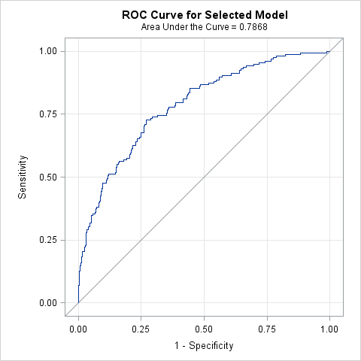

| **Hosmer and Lemeshow Goodness-of-Fit Test** | | |
| --- | --- | --- |
| **Chi-Square** | **DF** | **Pr > ChiSq** |
| 1.3444 | 8 | 0.9950 |

| **Odds Ratio Estimates and Profile-Likelihood Confidence Intervals** | | | | |  |
| --- | --- | --- | --- | --- | --- |
| **Effect** | **Unit** | **Estimate** | **95% Confidence Limits** | | **P value** |
| **age** | 5.0000 | 0.776 | 0.672 | 0.889 | 0.0004 |
| **gender Male vs Female** | 1.0000 | 2.029 | 1.221 | 3.393 | 0.0066 |
| **employ Unemployed vs Employed** | 1.0000 | 1.684 | 0.924 | 3.054 | 0.0867 |
| **trans Transport to clinic: (choice=Your car) vs Transport to clinic: (choice=All Other)** | 1.0000 | 1.871 | 0.957 | 3.658 | 0.0662 |
| **faith_act Not Active/No Religion vs Active** | 1.0000 | 1.728 | 1.083 | 2.766 | 0.0220 |
| **family_HIV_bin none vs 1-4** | 1.0000 | 0.622 | 0.384 | 1.006 | 0.0533 |
| **treat_support Yes vs No** | 1.0000 | 2.145 | 1.171 | 3.939 | 0.0134 |
| **tb Yes vs No** | 1.0000 | 0.698 | 0.437 | 1.108 | 0.1288 |
| **Cryptococcus Yes vs No** | 1.0000 | 0.068 | 0.002 | 0.859 | 0.0674 |
| **rhiv Who first recommended you to go to an HIV clinic? (Friend vs Family)** | 1.0000 | 0.434 | 0.191 | 0.945 | 0.0396 |
| **rhiv Who first recommended you to go to an HIV clinic? (Other vs Family)** | 1.0000 | 0.404 | 0.196 | 0.814 | 0.0124 |
| **rhiv Who first recommended you to go to an HIV clinic? (Provider (doctor or nurse)) vs Family)** | 1.0000 | 0.823 | 0.459 | 1.478 | 0.5125 |
| **arv_start Sinikithemba (Ridge House) vs Other** | 1.0000 | 0.533 | 0.251 | 1.139 | 0.1009 |
| **arv_train_bin 3+ vs 0-2** | 1.0000 | 0.315 | 0.105 | 0.896 | 0.0334 |
| **current_regimen Other vs D4T** | 1.0000 | 0.497 | 0.283 | 0.868 | 0.0141 |
| **current_regimen ZDV vs D4T** | 1.0000 | 0.613 | 0.299 | 1.238 | 0.1753 |
| **CO-TRIMOXAZOLE Yes vs No** | 1.0000 | 1.770 | 1.109 | 2.841 | 0.0172 |
| **FLUCONAZOLE Yes vs No** | 1.0000 | 15.495 | 2.677 | 295.431 | 0.0116 |
| **TBD ETHAMBUTOL Yes vs No** | 1.0000 | 2.922 | 0.778 | 12.402 | 0.1201 |

**Model 2 =Demo + Socieconomic +Psycho + Symptoms + Medical History + Medications**

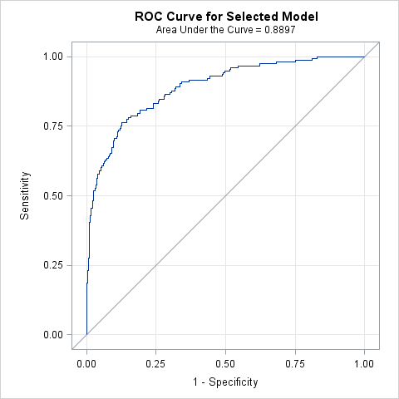

| **Hosmer and Lemeshow Goodness-of-Fit Test** | | |
| --- | --- | --- |
| **Chi-Square** | **DF** | **Pr > ChiSq** |
| 8.0582 | 8 | 0.4278 |

| **Odds Ratio Estimates and Profile-Likelihood Confidence Intervals** | | | | |  |
| --- | --- | --- | --- | --- | --- |
| **Effect** | **Unit** | **Estimate** | **95% Confidence Limits** | | **P value** |
| **age** | 5.0000 | 0.851 | 0.700 | 1.029 | 0.0992 |
| **gender Male vs Female** | 1.0000 | 2.246 | 1.221 | 4.171 | 0.0096 |
| **edu** | 1.0000 | 1.121 | 0.964 | 1.320 | 0.1531 |
| **trans Transport to clinic: (choice=Your car) vs Transport to clinic: (choice=All Other)** | 1.0000 | 1.824 | 0.781 | 4.292 | 0.1651 |
| **Depression Score 12+ vs 10 or 11** | 1.0000 | 3.041 | 1.635 | 5.830 | 0.0006 |
| **effort_bin Some,Most,All of the time vs No,A Little of time** | 1.0000 | 3.224 | 0.676 | 18.995 | 0.1588 |
| **faith Yes vs No** | 1.0000 | 0.524 | 0.220 | 1.237 | 0.1408 |
| **faith_act Not Active/No Religion vs Active** | 1.0000 | 1.544 | 0.857 | 2.792 | 0.1482 |
| **family_HIV_bin none vs 1-4** | 1.0000 | 0.533 | 0.293 | 0.958 | 0.0367 |
| **practice_safe_bin Often,Sometimes,Rarely,Never vs Always** | 1.0000 | 5.391 | 2.114 | 14.255 | 0.0005 |
| **treat_support Yes vs No** | 1.0000 | 1.957 | 0.889 | 4.292 | 0.0933 |
| **clinic_feel Pleased vs Neutral** | 1.0000 | 0.433 | 0.226 | 0.823 | 0.0108 |
| **symptom_fatigue Patient have symptom=Yes vs Patient have symptom=No** | 1.0000 | 2.646 | 1.453 | 4.886 | 0.0016 |
| **symptom_diarr Patient have symptom=Yes vs Patient have symptom=No** | 1.0000 | 2.489 | 1.012 | 6.123 | 0.0461 |
| **symptom_skin Patient have symptom=Yes vs Patient have symptom=No** | 1.0000 | 1.633 | 0.906 | 2.941 | 0.1017 |
| **log_cd4** | 1.0000 | 0.078 | 0.024 | 0.221 | <.0001 |
| **Lipodystrophy Yes vs No** | 1.0000 | 0.413 | 0.202 | 0.813 | 0.0126 |
| **arv_start Sinikithemba (Ridge House) vs Other** | 1.0000 | 0.447 | 0.183 | 1.093 | 0.0767 |
| **rhiv Who first recommended you to go to an HIV clinic? (Friend vs Family)** | 1.0000 | 0.308 | 0.113 | 0.793 | 0.0171 |
| **rhiv Who first recommended you to go to an HIV clinic? (Other vs Family)** | 1.0000 | 0.362 | 0.146 | 0.868 | 0.0251 |
| **rhiv Who first recommended you to go to an HIV clinic? (Provider (doctor or nurse)) vs Family)** | 1.0000 | 0.784 | 0.390 | 1.582 | 0.4952 |
| **current_regimen Other vs D4T** | 1.0000 | 0.470 | 0.234 | 0.933 | 0.0313 |
| **current_regimen ZDV vs D4T** | 1.0000 | 0.711 | 0.301 | 1.656 | 0.4315 |
| **ses_num 2-4 vs 0-1** | 1.0000 | 0.382 | 0.151 | 0.948 | 0.0392 |
| **ses_num 5+ vs 0-1** | 1.0000 | 0.447 | 0.155 | 1.254 | 0.1290 |
| **remember_meds___7 Yes vs No** | 1.0000 | 3.356 | 1.333 | 8.561 | 0.0103 |
| **CO-TRIMOXAZOLE Yes vs No** | 1.0000 | 0.646 | 0.330 | 1.247 | 0.1969 |
| **TBD ETHAMBUTOL Yes vs No** | 1.0000 | 2.983 | 0.590 | 16.073 | 0.1886 |

**Model 3 =Demo + Socieconomic +Psycho + Accesss**

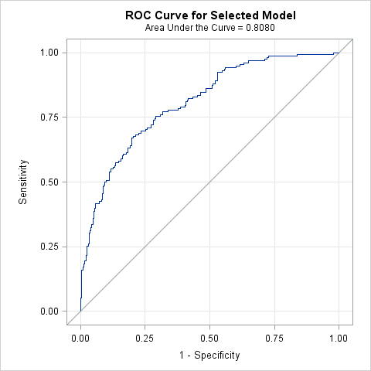

| **Hosmer and Lemeshow Goodness-of-Fit Test** | | |
| --- | --- | --- |
| **Chi-Square** | **DF** | **Pr > ChiSq** |
| 8.2001 | 8 | 0.4142 |

| **Odds Ratio Estimates and Profile-Likelihood Confidence Intervals** | | | | |  |
| --- | --- | --- | --- | --- | --- |
| **Effect** | **Unit** | **Estimate** | **95% Confidence Limits** | | **P value** |
| **age** | 5.0000 | 0.824 | 0.700 | 0.966 | 0.0186 |
| **gender Male vs Female** | 1.0000 | 2.556 | 1.524 | 4.319 | 0.0004 |
| **employ Unemployed vs Employed** | 1.0000 | 1.523 | 0.853 | 2.709 | 0.1528 |
| **edu** | 1.0000 | 1.125 | 0.995 | 1.288 | 0.0711 |
| **trans Transport to clinic: (choice=Your car) vs Transport to clinic: (choice=All Other)** | 1.0000 | 2.244 | 1.116 | 4.544 | 0.0236 |
| **dep_11 12+ vs 10 or 11** | 1.0000 | 3.021 | 1.840 | 5.060 | <.0001 |
| **effort_bin Some,Most,All of the time vs No,A Little of time** | 1.0000 | 5.139 | 1.305 | 26.173 | 0.0278 |
| **faith_specify Which one(s)? (choice=Christian) vs No religion** | 1.0000 | 0.478 | 0.241 | 0.949 | 0.0345 |
| **faith_specify Which one(s)? (choice=Muslim) vs No religion** | 1.0000 | <0.001 | . | 1.040 | 0.9839 |
| **faith_specify Which one(s)? (choice=Traditional African) vs No religion** | 1.0000 | 3.635 | 0.351 | 58.250 | 0.3317 |
| **family_HIV_bin none vs 1-4** | 1.0000 | 0.642 | 0.396 | 1.035 | 0.0693 |
| **practice_safe_bin Often,Sometimes,Rarely,Never vs Always** | 1.0000 | 2.903 | 1.345 | 6.441 | 0.0073 |
| **treat_support Yes vs No** | 1.0000 | 1.942 | 1.042 | 3.628 | 0.0364 |
| **clinic_feel Pleased vs Neutral** | 1.0000 | 0.322 | 0.184 | 0.557 | <.0001 |
| **Access (MPR from Enrollment)** | 0.1000 | 1.321 | 1.074 | 1.659 | 0.0117 |

**Model 4 =Demo + Psycho + Symptoms + Medical History + Medications + Adherence**

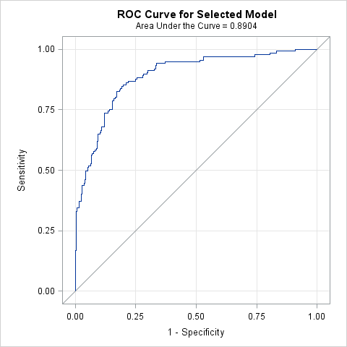

| **Hosmer and Lemeshow Goodness-of-Fit Test** | | |
| --- | --- | --- |
| **Chi-Square** | **DF** | **Pr > ChiSq** |
| 10.9240 | 8 | 0.2060 |

| **Odds Ratio Estimates and Profile-Likelihood Confidence Intervals** | | | | |  |
| --- | --- | --- | --- | --- | --- |
| **Effect** | **Unit** | **Estimate** | **95% Confidence Limits** | | **P value** |
| **age** | 5.0000 | 0.795 | 0.655 | 0.955 | 0.0164 |
| **gender Male vs Female** | 1.0000 | 2.930 | 1.530 | 5.731 | 0.0014 |
| **dep_11 12+ vs 10 or 11** | 1.0000 | 3.094 | 1.600 | 6.178 | 0.0010 |
| **effort_bin Some,Most,All of the time vs No,A Little of time** | 1.0000 | 4.722 | 0.895 | 29.526 | 0.0752 |
| **faith_act Not Active/No Religion vs Active** | 1.0000 | 1.445 | 0.793 | 2.636 | 0.2282 |
| **family_HIV_bin none vs 1-4** | 1.0000 | 0.561 | 0.300 | 1.041 | 0.0678 |
| **practice_safe_bin Often,Sometimes,Rarely,Never vs Always** | 1.0000 | 4.745 | 1.632 | 14.438 | 0.0049 |
| **treat_support Yes vs No** | 1.0000 | 1.754 | 0.771 | 3.990 | 0.1779 |
| **clinic_feel Pleased vs Neutral** | 1.0000 | 0.470 | 0.236 | 0.929 | 0.0301 |
| **symptom_fatigue Patient have symptom=Yes vs Patient have symptom=No** | 1.0000 | 1.994 | 1.037 | 3.871 | 0.0394 |
| **symptom_diarr Patient have symptom=Yes vs Patient have symptom=No** | 1.0000 | 1.704 | 0.622 | 4.569 | 0.2923 |
| **symptom_sleep Patient have symptom=Yes vs Patient have symptom=No** | 1.0000 | 1.871 | 0.886 | 3.967 | 0.1000 |
| **symptom_head Patient have symptom=Yes vs Patient have symptom=No** | 1.0000 | 1.439 | 0.754 | 2.753 | 0.2692 |
| **symptom_hair Patient have symptom=Yes vs Patient have symptom=No** | 1.0000 | 0.490 | 0.158 | 1.433 | 0.2007 |
| **sympt_caused No vs N/A** | 1.0000 | 0.164 | 0.022 | 1.473 | 0.0782 |
| **sympt_caused Yes vs N/A** | 1.0000 | 0.332 | 0.044 | 3.041 | 0.2878 |
| **karn_score** | 10.0000 | 1.548 | 0.887 | 2.780 | 0.1347 |
| **log_cd4** | 1.0000 | 0.061 | 0.018 | 0.180 | <.0001 |
| **Lipodystrophy Yes vs No** | 1.0000 | 0.402 | 0.188 | 0.826 | 0.0153 |
| **Duration of ART** | 1.0000 | 1.009 | 0.993 | 1.026 | 0.2625 |
| **arv_start Sinikithemba (Ridge House) vs Other** | 1.0000 | 0.531 | 0.209 | 1.362 | 0.1822 |
| **rhiv Who first recommended you to go to an HIV clinic? (Friend vs Family)** | 1.0000 | 0.172 | 0.055 | 0.495 | 0.0016 |
| **rhiv Who first recommended you to go to an HIV clinic? (Other vs Family)** | 1.0000 | 0.218 | 0.081 | 0.557 | 0.0019 |
| **rhiv Who first recommended you to go to an HIV clinic? (Provider (doctor or nurse)) vs Family)** | 1.0000 | 0.650 | 0.309 | 1.368 | 0.2559 |
| **current_regimen Other vs D4T** | 1.0000 | 0.401 | 0.193 | 0.826 | 0.0136 |
| **current_regimen ZDV vs D4T** | 1.0000 | 0.545 | 0.219 | 1.328 | 0.1848 |
| **remember_meds (Media(TV/Radio)) Yes vs No** | 1.0000 | 3.238 | 1.283 | 8.396 | 0.0137 |
| **FLUCONAZOLE Yes vs No** | 1.0000 | 4.539 | 0.714 | 33.833 | 0.1227 |
| **Adherence** | 0.1000 | 1.305 | 0.972 | 1.771 | 0.0812 |

**Model 5 =Demo + Socieconomic +Psycho + Symptoms + Medical History + Medications + Access + Adherence**

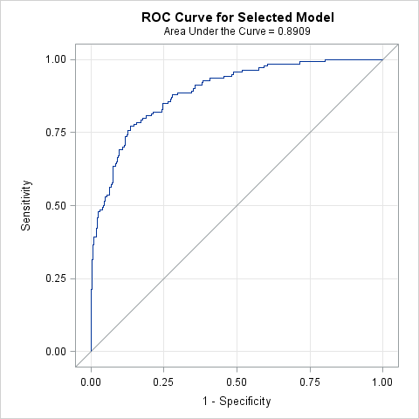

| **Hosmer and Lemeshow Goodness-of-Fit Test** | | |
| --- | --- | --- |
| **Chi-Square** | **DF** | **Pr > ChiSq** |
| 3.3217 | 8 | 0.9126 |

| **Odds Ratio Estimates and Profile-Likelihood Confidence Intervals** | | | | |  |
| --- | --- | --- | --- | --- | --- |
| **Effect** | **Unit** | **Estimate** | **95% Confidence Limits** | | **P value** |
| **age** | 5.0000 | 0.821 | 0.667 | 1.005 | 0.0589 |
| **gender Male vs Female** | 1.0000 | 2.446 | 1.286 | 4.713 | 0.0068 |
| **edu** | 1.0000 | 1.146 | 0.986 | 1.351 | 0.0886 |
| **trans Transport to clinic: (choice=Your car) vs Transport to clinic: (choice=All Other)** | 1.0000 | 1.997 | 0.808 | 4.957 | 0.1334 |
| **Depression Score 12+ vs 10 or 11** | 1.0000 | 3.476 | 1.806 | 6.925 | 0.0003 |
| **effort_bin Some,Most,All of the time vs No,A Little of time** | 1.0000 | 4.159 | 0.728 | 31.015 | 0.1294 |
| **faith Yes vs No** | 1.0000 | 0.520 | 0.207 | 1.302 | 0.1614 |
| **faith_act Not Active/No Religion vs Active** | 1.0000 | 1.409 | 0.761 | 2.612 | 0.2742 |
| **family_HIV_bin none vs 1-4** | 1.0000 | 0.569 | 0.307 | 1.047 | 0.0708 |
| **practice_safe_bin Often,Sometimes,Rarely,Never vs Always** | 1.0000 | 4.731 | 1.694 | 13.726 | 0.0034 |
| **treat_support Yes vs No** | 1.0000 | 1.787 | 0.802 | 3.953 | 0.1516 |
| **clinic_feel Pleased vs Neutral** | 1.0000 | 0.423 | 0.215 | 0.829 | 0.0123 |
| **symptom_fatigue Patient have symptom=Yes vs Patient have symptom=No** | 1.0000 | 2.234 | 1.188 | 4.231 | 0.0128 |
| **symptom_diarr Patient have symptom=Yes vs Patient have symptom=No** | 1.0000 | 1.940 | 0.738 | 5.025 | 0.1732 |
| **symptom_sad Patient have symptom=Yes vs Patient have symptom=No** | 1.0000 | 1.392 | 0.737 | 2.612 | 0.3043 |
| **symptom_skin Patient have symptom=Yes vs Patient have symptom=No** | 1.0000 | 1.726 | 0.925 | 3.220 | 0.0855 |
| **log_cd4** | 1.0000 | 0.064 | 0.018 | 0.199 | <.0001 |
| **Lipodystrophy Yes vs No** | 1.0000 | 0.486 | 0.233 | 0.976 | 0.0471 |
| **Duration of ART** | 1.0000 | 1.008 | 0.993 | 1.024 | 0.2888 |
| **rhiv Who first recommended you to go to an HIV clinic? (Friend vs Family)** | 1.0000 | 0.252 | 0.084 | 0.705 | 0.0107 |
| **rhiv Who first recommended you to go to an HIV clinic? (Other vs Family)** | 1.0000 | 0.375 | 0.148 | 0.920 | 0.0351 |
| **rhiv Who first recommended you to go to an HIV clinic? (Provider (doctor or nurse)) vs Family)** | 1.0000 | 0.923 | 0.445 | 1.937 | 0.8316 |
| **current_regimen Other vs D4T** | 1.0000 | 0.384 | 0.187 | 0.781 | 0.0086 |
| **current_regimen ZDV vs D4T** | 1.0000 | 0.617 | 0.246 | 1.518 | 0.2960 |
| **remember_meds by Media(TV/Radio) Yes vs No** | 1.0000 | 3.183 | 1.259 | 8.151 | 0.0146 |
| **CO-TRIMOXAZOLE Yes vs No** | 1.0000 | 0.702 | 0.335 | 1.456 | 0.3430 |
| **FLUCONAZOLE Yes vs No** | 1.0000 | 3.089 | 0.544 | 21.361 | 0.2228 |
| **Access (MPR from Enrollment)** | 0.1000 | 1.521 | 1.124 | 2.126 | 0.0094 |